Help Spread the Word
We encourage you to help us raise awareness of the Virginia Mortgage Relief Program. This document outlines both Twitter and Facebook social media copy and graphics. If you have any issues accessing the graphics, please reach us at outreach@virginiamortgagerelief.com

Twitter Copy & Graphics (English and Spanish)

Post 1_English | Twitter
Starting today, #VMRP max. assistance is raised to $50K & the delinquency start date requirement adjusted. To be eligible, homeowners must have experienced a #COVID19 related financial hardship. Apply today ➡ 833-OUR-VMRP or VirginiaMortgageRelief.com 🏡 #MortgageRelief

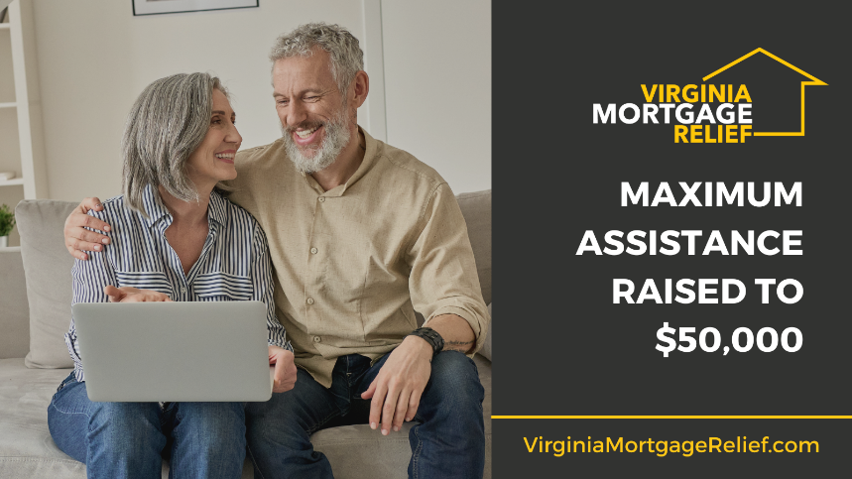

Post 1_Spanish | Twitter
A partir de hoy, la asistencia máxima de #VMRP ha aumentado a $50k y se ajusta el requisito de fecha de inicio de la morosidad. Para ser elegible, los propietarios deben haber experimentado dificultades financieras relacionadas con #COVID19. Solicite hoy ➡ 833-OUR-VMRP 🏡

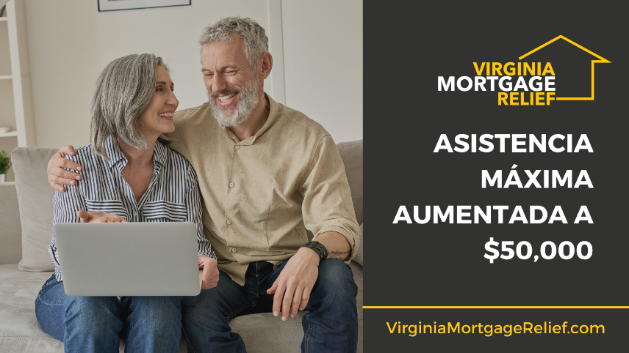

Post 2_English | Twitter
The Virginia Mortgage Relief Program offers relief to Virginia’s homeowners financially impacted by the COVID-19 pandemic. Begin your application today to determine your eligibility for assistance – Visit 💻 https://bit.ly/3lqIaG4 or call 📞 833-687-8677 #VMRP #MortgageRelief

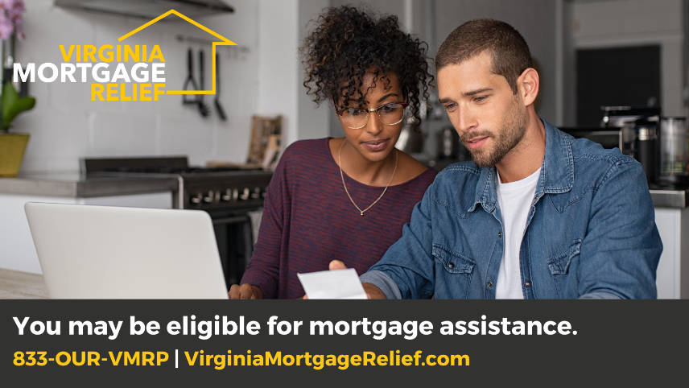

Post 2_Spanish | Twitter
El Programa de Alivio Hipotecario de Virginia ofrece alivio a propietarios en Virginia afectados económicamente después de la pandemia de #COVID19. Comience su solicitud hoy para determinar su elegibilidad 💻 https://bit.ly/3lqIaG4 📞 833-687-8677 #VMRP #AlivioHipotecario

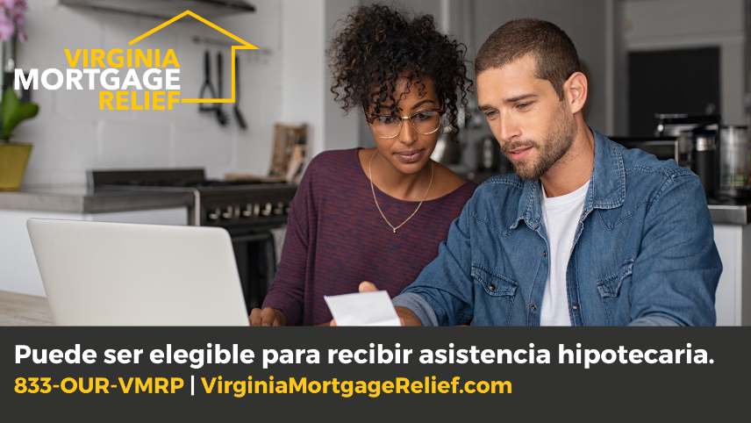

Post 3_English | Twitter

Are you struggling to pay mortgage & other housing-related expenses? #COVID19 recovery assistance is available to eligible Virginia homeowners through the Virginia Mortgage Relief Program. Apply today 💻 https://bit.ly/3lqIaG4 📞 833-687-8677
#VMRP #MortgageRelief

Post 3_Spanish | Twitter
¿Tiene dificultades para pagar la hipoteca y otros gastos relacionados con la vivienda? Asistencia recuperación de #COVID19 está disponible a través del Programa de Alivio Hipotecario de Virginia. Solicite hoy 💻https://bit.ly/3lqIaG4 📞 833-687-8677
#VMRP #AlivioHipotecario

Facebook Copy & Graphics (English & Spanish)

Post 1_English | Facebook
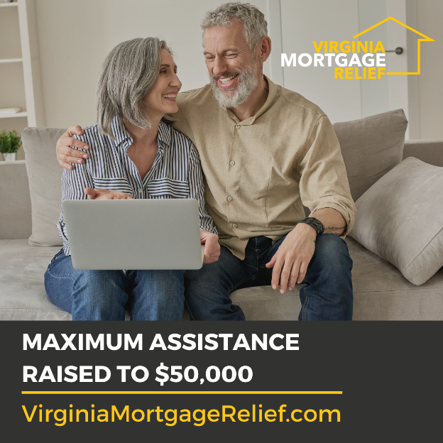
The Virginia Mortgage Relief Program, or VMRP, continues to work with Virginia homeowners experiencing financial hardship due to #COVID19

Starting today, the #VMRP maximum assistance is raised to $50,000 and the delinquency start date has been adjusted so that homeowners with a delinquency related to a COVID-19 hardship experienced after January 21, 2020 (including a hardship that began before January 21, 2020, but which continued after that date), which materially reduced income or increased living expenses, are now eligible for VMRP assistance.

Need assistance? Call 833-OUR-VMRP or visit VirginiaMortgageRelief.com today to learn more and apply for this limited funding #MortgageRelief

Post 1_Spanish | Facebook
El Programa de Alivio Hipotecario de Virginia, o VMRP, continúa trabajando con los propietarios de viviendas de Virginia 🏡 que experimentan dificultades financieras debido a #COVID19.

A partir de hoy, la asistencia máxima de #VMRP se eleva a $50,000 y la fecha de inicio de la morosidad se ha ajustado para que los propietarios de viviendas con una morosidad relacionada con una dificultad de COVID-19 experimentada después del 21 de enero de 2020 (incluida una dificultad que comenzó antes del 21 de enero de 2020 , pero que continuaron después de esa fecha), que redujeron significativamente los ingresos o aumentaron los gastos de subsistencia, ahora son elegibles para recibir asistencia del VMRP.

¿Necesita ayuda? Llame al 833-OUR-VMRP hoy o visite VirginiaMortgageRelief.com para obtener más información y solicitar este financiamiento limitado #AlivioHipotecario

Post 2_English | Facebook
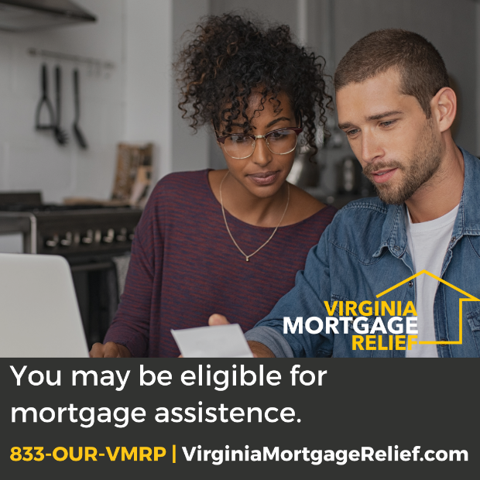
The Virginia Mortgage Relief Program or #VMRP, offers relief to Virginia homeowners financially impacted by the COVID-19 pandemic, such as a job loss or wage reduction.

Begin your application today to determine your eligibility for assistance.

Get started
💻 www.VirginiaMortgageRelief.com
📞 833-687-8677
#MortgageRelief #COVID19relief

Post 2_Spanish | Facebook
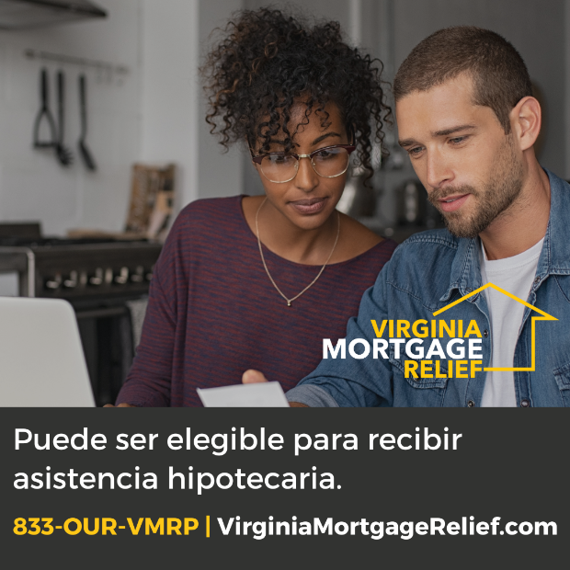
El Programa de Alivio Hipotecario de Virginia o #VMRP, ofrece alivio a propietarios en Virginia afectados económicamente después de la pandemia de #COVID19, como la pérdida del trabajo o la reducción del salario.

Comience su solicitud para determinar su elegibilidad

Empiece hoy
💻https://bit.ly/3lqIaG4
📞 833-687-8677
#AlivioHipotecario #RecuperacionCOVID

Post 3_English | Facebook
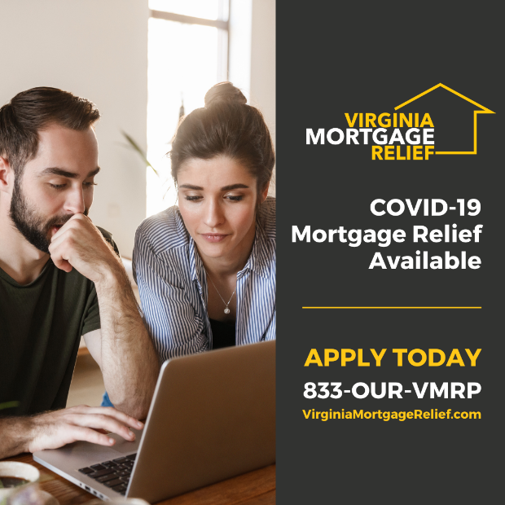
Are you struggling to pay mortgage and other housing-related expenses due to a financial hardship stemming from the #COVID19 pandemic?
Recovery assistance is now available to eligible Virginia homeowners through the Virginia Mortgage Relief Program, or #VMRP.
Apply today 💻 www.VirginiaMortgageRelief.com or 📞 833-687-8677.
#MortgageRelief

Post 3_Spanish | Facebook
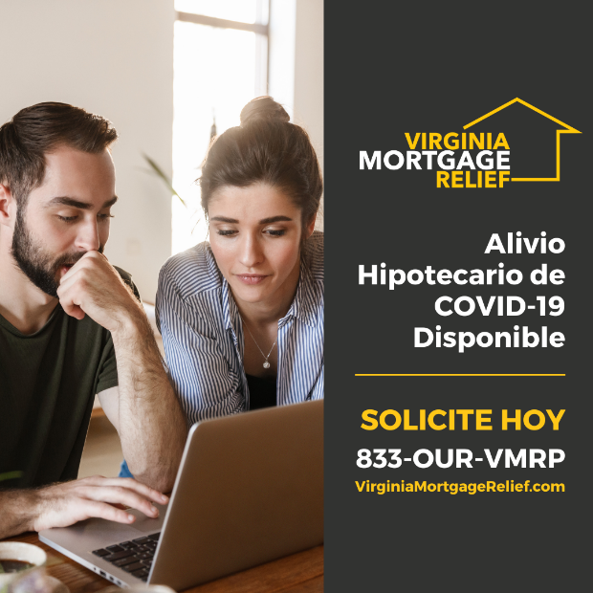
¿Tiene dificultades para pagar la hipoteca y otros gastos relacionados con la vivienda debido a dificultades financieras derivadas de la pandemia de #COVID19? Asistencia está disponible para propietarios a través del Programa de Alivio Hipotecario de Virginia o #VMRP.

Solicite hoy 💻www.VirginiaMortgageRelief.com o 📞 833-687-8677
#AlivioHipotecario

